University of Reading
The Mary Bryden Studentship in Samuel Beckett Studies

For entry September 2026 or January 2027.

We are delighted to announce the Mary Bryden Studentship in Beckett Studies at the University of Reading. Supported by an endowment from our colleague Professor Mary Bryden’s Estate, the Ph. D. studentship offers an annual subsistence stipend of £13,500 for 3 years full-time study, or part-time equivalent. The scholarship will also cover full-time UK/Republic of Ireland tutorial fees of £5238 fees.

Further information on fees can be found on the University’s Graduate Studies website: https://www.reading.ac.uk/doctoral-researcher-college/funding/fees/fees-new-students

It is possible that, for a suitably-qualified candidate, the Samuel Beckett Interdisciplinary Research Centre can offer a small supplementary further income in exchange for input to the support and sustainability of our activities.

The studentship is open to highly qualified applicants proposing to study any aspect of Samuel Beckett’s work towards a Ph.D. at the University of Reading. Preference will be given, given the provenance of the studentship, to candidates who are planning to undertake part of their research at the world-leading archive of Beckett materials, housed at the University’s Special Collections: https://collections.reading.ac.uk/special-collections/collections/samuel-beckett-writer/

The successful candidate will be based at the Samuel Beckett Interdisciplinary Research Centre at the University. Further details are provided below.

The closing date for applications to the Studentship is 30th June 2026. Details of how to apply are given below.

Professor Mary Bryden died in 2015; she was a loved and respected colleague in French Studies in the Department of Modern Languages and European Studies, of which she was a sometime Head. Mary’s research specialities lay chiefly in the sphere of twentieth-century French literature, philosophy, and culture, and she worked intensively on Samuel Beckett, Gilles Deleuze, Hélène Cixous, T. E. Lawrence and Thomas Merton. Her books include Women in Samuel Beckett's Prose and Drama, Samuel Beckett and the Idea of God, Beckett's Proust/Deleuze's Proust (jointly with M. Topping), and a number of edited books, such as Samuel Beckett and Music, and Beckett and Animals.

The University of Reading leads the world in resources and expertise for the study of Samuel Beckett. In addition to the renowned Beckett archives held in Special Collections, experts working at Reading include Professor Conor Carville, Professor Mark Nixon and Emeritus Professor Steven Matthews in English, Dr John McKeane in Modern Languages, Dr Michela Bariselli and Professor Maximillian De Gaynesford in Philosophy, and Professor Jonathan Bignell and Dr Matthew McFrederick in Film, Theatre and Television. You can find their staff pages on the relevant department websites.

How to apply

The closing date for applications, either for September 2026 or January 2027 entry, is 30th June 2026. Applications should be sent direct to Professor Conor Carville at c.carville@reading.ac.uk, with the subject line ‘Mary Bryden Studentship’.

The applications should contain three elements; 1. A research proposal of c.1,500 words, outlining the proposed project. The proposal should contain a Methodology section, and a section describing the relation of the proposed project to the archival holdings in the Beckett Collection at the University of Reading; 2. A Bibliography of primary sources and relevant secondary criticism; 3. A full CV.

The successful candidate will be required to apply to the University through the formal PhD application portal – but only once the Panel decision awarding the Studentship has been announced.

The Samuel Beckett Interdisciplinary Research Centre
The University of Reading holds the Samuel Beckett collection; the world’s largest collection of resources relating to the work of one of the twentieth century’s most significant writers. Highlights of this collection include the Knowlson Collection, the Billie Whitelaw Collection, and the six manuscript notebooks of Beckett’s first major novel Murphy.
The University is also home to the Samuel Beckett Interdisciplinary Research Centre, a hub for the advancement of scholarly and creative engagement with the works of Samuel Beckett, an engagement partly drawing on these archives of Beckett materials held in the University of Reading's Special Collections.
The Samuel Beckett IDRC is an active community of scholars and writers from a range of disciplines across the University and beyond, undertaking internationally acclaimed research, and producing new creative work, on Beckett. The Centre staff and adjuncts come from all career levels, including post-doctoral and doctoral researchers, and Masters students, as well as creative and research associates from both within and outside of the University. Our support for PhDs in Beckett Studies draws on decades of expertise and engagement.
The Mary Bryden Samuel Beckett Studentship.
The long-term vision for the Mary Bryden Samuel Beckett Studentship is to nurture and support the next generation of Beckett Scholars who will, in perpetuity, promote interdisciplinary research on Beckett and promote his relevance to global issues, issues, including such issues as mental health and “post-truth” politics.


Studying for a PhD in Beckett at the University of Reading
The University of Reading has an established track record of supervising graduate work in Beckett studies. PhD students in the Samuel Beckett IDRC benefit from and contribute to a strong and established culture, and join a vibrant community, which spans research and researchers from English Literature, Film, Theatre and Television, Modern Languages, and Philosophy.
In addition to our experienced academic staff, our PhD students work alongside a thriving group of postdoctoral researchers who recently completed their PhDs and can advise students as they pursue their own research. PhD students are supervised by world-renowned researchers, many of whom have extensive experience of working or living overseas. Students also have many opportunities to interact with, and to learn from, international academics and students, through academic study, seminars and conferences, and social events.
All PhD students at Reading are encouraged to undertake the qualification courses to teach in Higher Education.
Conferences: We ensure there are plenty of opportunities for our PhD students to communicate their work and network with other researchers, present seminars, speak at Reading-hosted Beckett conferences and workshops, and visit or host researchers from other institutions. Students attend research seminars hosted by the Centre, often featuring internationally renowned speakers. These collaborative exercises allow ideas to flow and spread through the international Beckett community quickly and effectively.
Archival Work: We encourage all of our research students to undertake a certain amount of archival work during the period of their studentship. As part of the aim of the Mary Bryden Samuel Beckett Studentship, we would like the recipient to work in the Beckett archives at Special Collections, in order to increase their own skills and experience, and to enable the production of unique and original research in the final thesis.
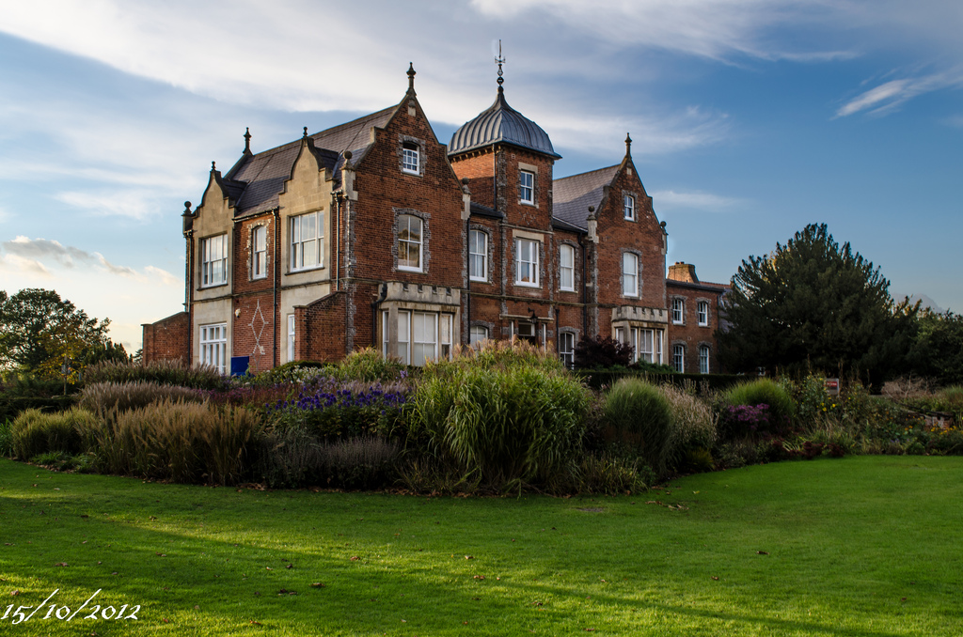
The Graduate School: All our PhD students automatically become members of the University-wide Graduate School. The Graduate School provides training, professional development, study space, advice and administrative support in a dedicated building for the postgraduate research community at Reading.

Make up of Studentship Appointments Panel
To ensure that the most appropriate student is chosen interviews will be conducted by a 3-person panel:
- The Co-Directors of the Beckett Research Centre
- The Dean of Research with responsibility for the School of Literature and Languages
- A representative of the Beckett International Foundation

